ENDNOTE (EN) DESKTOP QUICK GUIDE

Create an EndNote Library

On the top menu select File > New. Type in the name of the library. Designate the folder where you want to save.

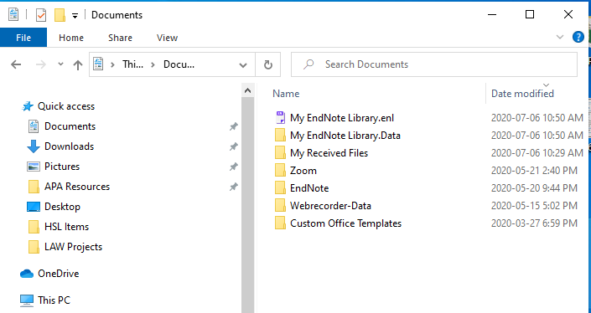

Add References to an EndNote Library

Add References from Databases

PubMed
- Search and select each reference needed. Select Send To in the top right.
- Select Citation manager and choose Create File.
- If using Firefox, choose ResearchSoft Direct Export Helper for direct export
- For other browsers, choose Save File (.nbib) > in EndNote > go to File > choose Import > locate the .nbib file > under Import option, select Pubmed from the drop down menu > click Import
To export all search results, go to Send To > Citation Manager > choose All Results > click on Create File > Export
Medline (OVID)
- Search and select each reference needed. Select Export from the results menu bar.
- Change Format to EndNote, change Fields to Complete Reference
- Click Export. If using Firefox, choose Open with ResearchSoft Direct Export Helper for direct export
- For other browsers, choose Save File (.cgi) > in Endnote > go to File > choose Import > locate the .cgi file > under Import Option, select Medline OvidSP from the drop down menu > click Import
To export batches up to 1000, specify a range of results (e.g. 1-1000) in step 1 if you do not select references.

CINAHL (EBSCO)
- Search and then click Add to Folder (blue folder icon) for each reference needed.
- Go to Folder from the top menu or the right hand column.
- Select references for export. Click Export.
- Choose Direct Export in RIS Format and then select Save.

To export All Results, click on the Share menu, under Export Results: Email a link… > choose RIS Format > select Send. You will be e-mailed a link to a .zip file. Download and extract the file into a .ris file > Import into EndNote

Google Scholar
- Click the Options button (three horizontal lines next to the Google Scholar logo)
- Select the Settings menu, Under Bibliography Manager, go to Show links to import citation into and on the drop down menu, select Refman, click Save.
- Perform your search and select citations to add to EndNote library. Choose Import into Refman.
- Select Open with EndNote X9 if using Firefox or save file and import using .RIS filter option.
- You can import one reference at a time or multiple references.

You need a Google account to import multiple references and will need to login before selecting multiple citations. On the results lists page, choose references by clicking on the star icon at the bottom of each citation. The star icon changes into blue.

When selection is complete, go to My Library (top right corner). The marked references are shown. Select All references by clicking on the square icon and selecting EndNote from the download icon. Select Open With Endnote X9 if using Firefox or Save File and import using .RIS filter option. References are imported to Endnote.

Organize References

Make it easy to view your references by creating groups. On the top menu, select Groups > Create Group Set or Group or Smart Group.

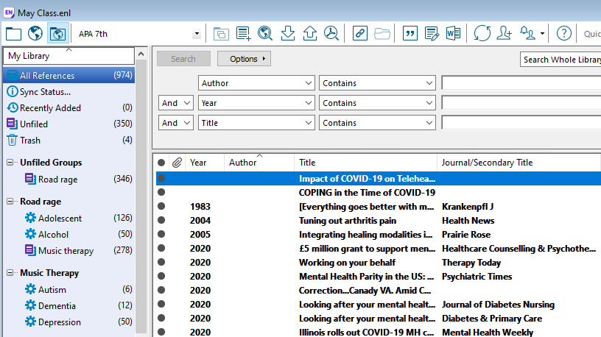
Group set
Smart groups
Groups

Import References from PDFs

We recommend importing records from research databases like PubMed since this is the best way to ensure your EN records are accurate and complete. If you import PDF files, EN automatically generates EN records for each PDF, but sometimes the EN record is not complete or accurate.

Add References Manually

Use this as a last resort if you are not able to import records from a database. Under the References tab> Add New Reference > Remember to click Save once all the data has been entered.

Find Duplicates

On the top menu bar References > Find Duplicates. Compare references on the side by side window and decide which version to Keep.

To remove and track duplicates for systematic or scoping reviews check videos, step-by-step instructions at: https://library.ucalgary.ca/srskills

Find Full-Text (FFT)

Within Endnote, On the Edit menu bar, go to Preferences > Find Full Text
Find the two Find Full Text URL paths from the Citing and Writing in the Health Sciences Guide
Go to the EndNote Desktop page, choose the Find Full Text tab
Copy and paste the Open URL path and the Authenticate with URL path (see below).
Click Apply > Click OK.

Open URL Path http://ucalgary-primo.hosted.exlibrisgroup.com/openurl/01UCALG/UCALGARY
Authenticate With URL: http://ezproxy.lib.ucalgary.ca/login

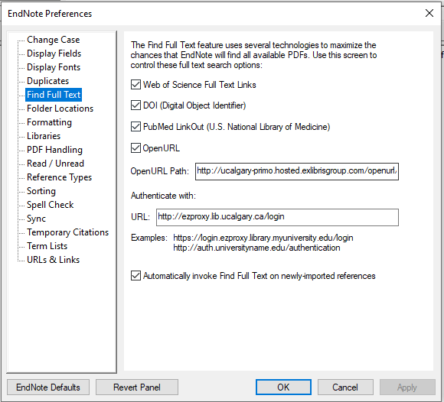

Highlight the records in your EN library, then click on the Find Full Text icon on the top menu bar

Cite While You Write (CWYW)

The CWYW plug-in installs automatically when you load EN desktop onto your computer. Use CWYW with MS Word to insert references, edit citations and format bibliographies.
In EN for Windows > Within Word > go to the Endnote tab
In EN for Macs > activate a floating Endnote toolbar. (Use the View menu to find the toolbar option).

Share References
Share Groups with Multiple Users: Highlight a Group to share > click on thebutton > enter the email address/addresses of the people that you would invite in the email box > click the Invite button

Share an entire EN Library: From the top menu bar > go to File > Compressed Library (.enlx) > email the .enlx file

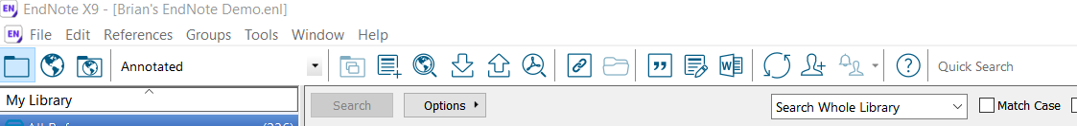
Activity Feed: Click on the Activity Feed button to see changes made to your shared libraries

Copyright: U of C’s licensing agreements restricts sharing only among UofC Endnote users

Keeping Your EndNote Libraries Healthy

- EN libraries consist of a .enl file and .data folder. Both parts are needed for the library to work correctly
- EN libraries should not be stored in cloud-syncing folders such as Dropbox, OneDrive, SugarSync since these can corrupt EN libraries over time
- Uninstall a previous version before installing an updated Endnote program

Software Support and Training

We provide basic client support only. For in-depth support, contact EndNote Technical Support at: https://endnote.com/contact/

EndNote (Clarivate, producer of EndNote) http://clarivate.libguides.com/endnote_training/users/enx9

EndNote Knowledgebase (FAQ) https://support.clarivate.com/Endnote/s/?language=en_US

Citing and Writing in the Health Sciences: https://library.ucalgary.ca/guides/hsl/citationmanagementtools

Feel free to connect with me personally for specific EndNote questions. Lourdes Yturzaeta

Health Sciences Library, University of Calgary 3330 Hospital Drive NW
Email: hslibr@ucalgary.ca
Phone: 403-220-6855

